Haley Gumm and Avery Peerce
ePublishing
12-17-12

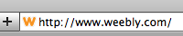
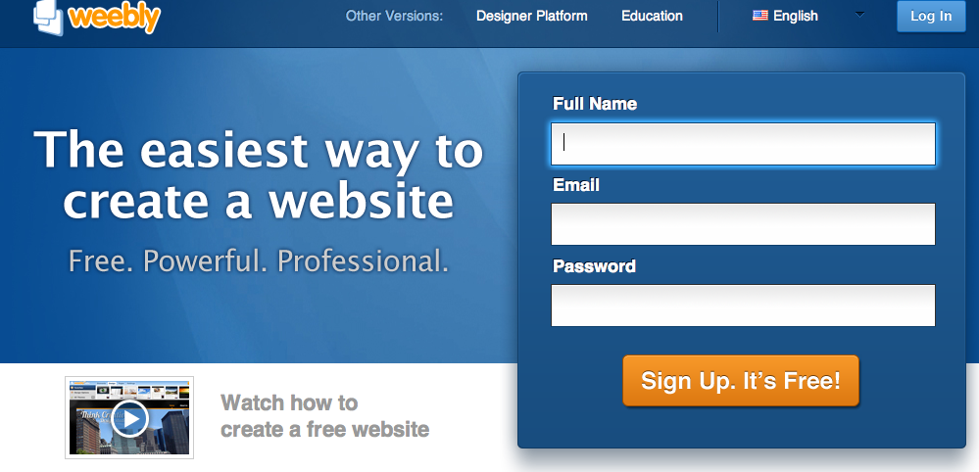
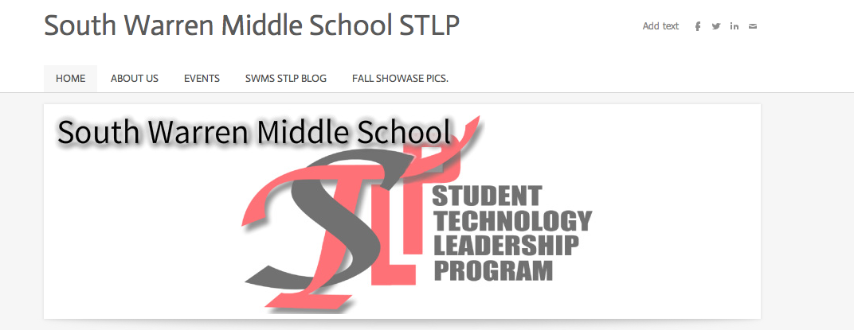
We made a website called www.swmsstlp.weebly.com . Our website purpose is to teach you about South Warren Middle School’s STLP. We created this website by:

First- We logged on to www.weebly.com.

Second- We created an account and a website name.

Third- We chose pictures to put so everyone could see what our website was.

Fourth- We wrote down events such as when the STLP projects were due and when we were heading to Fall Showcase.

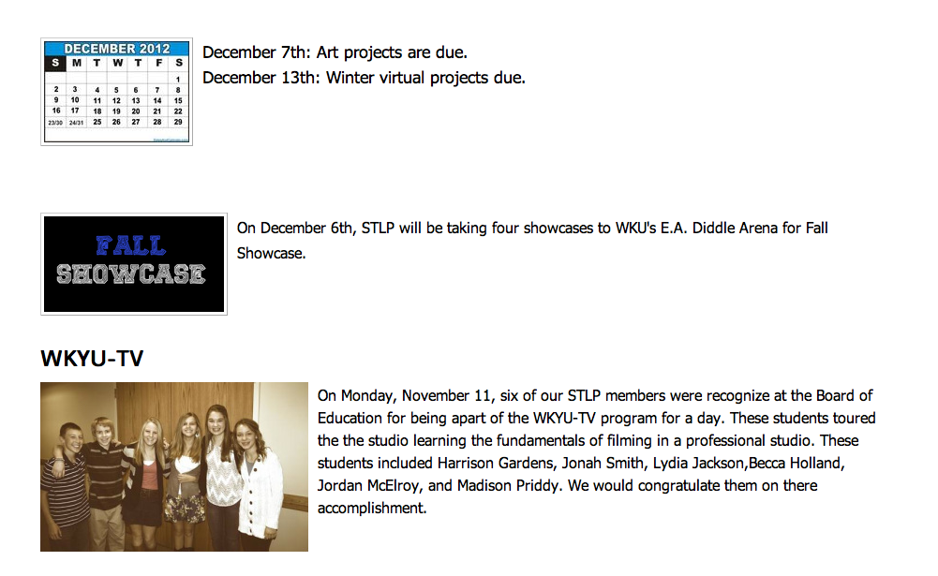
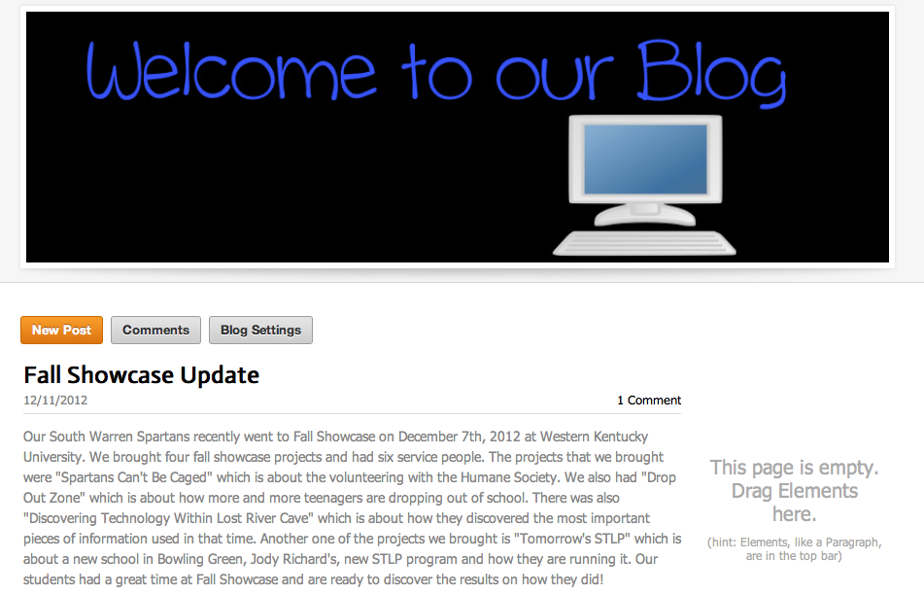
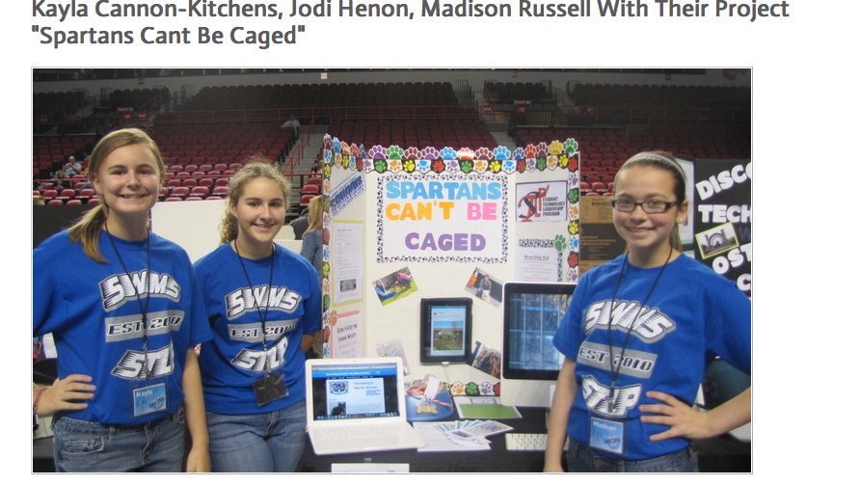
Fifth- We waited after fall showcase and then added how our STLP did at Fall Showcase and pictures of everyones’ projects and what a fun time they had.

